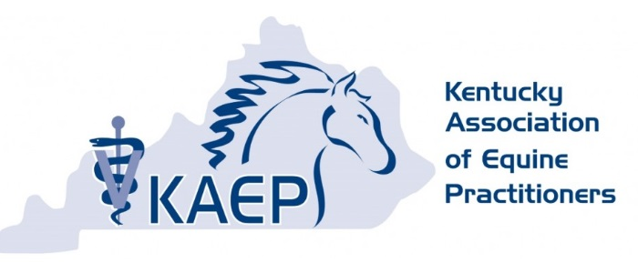
FOR IMMEDIATE RELEASE

CONTACT:
Kentucky Association of Equine Practitioners
330 518 9001 /kaepoffice@gmail.com

The World is Watching: How are Different Facets of Horse Sport Handling Public Scrutiny?
A cohesive defense of equine sport is paramount to its survival

Lexington, KY (September 9, 2024) – The term “social license to operate” (SLO) is no longer a buzzword and its ramifications are being felt throughout the equine realm. Referring to stakeholder perception of an entity’s legitimacy, SLO will truly decide the fate of the equine industry. The Kentucky Association of Equine Practitioners, in conjunction with the Kentucky Thoroughbred Farm Managers’ Club, will host a meeting addressing SLO and how it is being addressed on Tuesday, October 8, from 6 to 8 p.m. at Copper Roux in Lexington, Kentucky.

Although humans have had a relationship with horses for centuries, public scrutiny of equine welfare is increasing, and the onus is on horse owners, trainers, breeders and riders to show the public that they are mindful of their horse’s physical and mental well-being. Whether used for racing, competition or leisure, how horses are bred, managed, trained, competed and retired will affect the ability of equestrianism to continue.

A panel of stakeholders in the equine industry will address how different factions of the equine industry are addressing SLO and offer insight into how the entire industry can work together to ensure the future of horse sport remains bright.
Panelists include:
- Chip Johnson, DVM, partner at Equine Medicine and Surgery
- Roderick Wachman, breeder, consignor and owner of Roderick Wachman Bloodstock
- David O’Connor, Chief of Sport for the US Equestrian Federation
- Natalie Voss, Editor-in-Chief of the Paulick Report
- Ron Moquett, multiple graded stakes winning Thoroughbred racehorse trainer

Emma Adam, B.Vet.Med, Dipl. ACVIM, ACVS, Associate Professor at the Gluck Equine Research Center, will moderate

“Though the public generally supports horse sport, it’s clear that we are all under the microscope, no matter our involvement with horses,” says Larkspur Carroll, DVM, President of the KAEP and owner of Core Therapies, a veterinary chiropractic and acupuncture clinic based in Salvisa, Kentucky. “To not address public scrutiny and simply carry on as we always have is no longer an option. To continue to enjoy the horses, we as an industry must understand that this issue crosses all breed and discipline boundaries; we have to work together to show the world that we are deeply concerned with our horse’s health and welfare – and that we’re willing to change to ensure we can continue doing what we love.”

Dinner is included with ticket price and questions are encouraged.

For details and reservations for the October 8 event, click here. Tickets are $35. Interested in sponsoring this event? Email kaepoffice@gmail.com.

####
ABOUT THE KENTUCKY ASSOCIATION OF EQUINE PRACTITIONERS: The Kentucky Association of Equine Practitioners is a nonprofit organization dedicated to the professional development of its members by promoting fellowship, providing educational opportunities, and informing members of political, social, and emerging disease issues that affect the veterinary community. KAEP also focuses on enabling its members to provide quality care for the horse. Learn more at kaep.info

